2022—2023 学年 第一学期
学校 班级 姓名 学号
………………………密…………封…………线…………内…………不…………准…………答…………题………………………
八年级英语兴趣小组辅导练习（四）
（练习时间：50分钟 分值：70分 ）

一、完形填空（共15小题，每小题1分，计15分）
We sometimes call the lion “the king of the jungle” because it is stronger and more dangerous than other animals. It can 1 faster than many animals and it can hunt the best. It is the highest animal in the 2 food chain (食物链).
In the sea, the shark is one of the animals at the 3 of the food chain. It can swim faster than 4 other sea animals, and it can use its big teeth to eat them.
What is at the top of the world’s food chain? 5 are! We are not the biggest or fastest, but we are the 6 . We could not run faster than cheetahs (猎豹), so we 7 cars and now we can move the fastest. We could not 8 better than lions, so we invented guns (枪). Now we can hunt the best.
People’s inventions are clever, but they can be 9 , too. For example, people invented 10 , and now they make the air and rivers dirty. This can make 11 changes. Dirty rivers kill fish. 12 bears cannot eat the fish and the bears die. If we kill one part of the food chain, 13 also die. Remember that we are a part of the food chain, 14 we are in danger too! If we protect animals, we are protecting 15 ! We should and we could do something for the world!
( )1. A. walk B. run C. swim D. jump
( )2. A. land B. sea C. mountain D. desert
( )3. A. front B. end C. top D. beginning
( )4. A. some B. any C. more D. most
( )5. A. Humans B. Lions C. Sharks D. Cheetahs
( )6. A. Strongest B. cleverest C. most special D.most important
( )7. A. used B. had C. made D. invented [来
( )8. A. fight B. escape C. kill D. catch
( )9. A. dangerous B. interesting C. useful D. helpful[来源:学科
( )10. A. hotels B. schools C. factories D. hospitals
( )11. A. great B. terrible C. wonderful D. complete
( )12. A. If B. When C. Then D. While
( )13. A. one part B. another part C. other parts D. the other parts
( )14. A. and B. but C. or D. so
( )15. A. oneself B. yourselves C. themselves D. ourselves

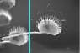
二、阅读理解（阅读并选出最佳答案，共5小题，每小题2分，计10分）
Look at the plant in the picture. It looks beautiful, right? Can you imagine (想象) it kills? The Venus flytrap is a kind of meat-eating plant. It grows in very few places, like wetlands near the sea in North Carolina in America.
The Venus flytrap is not a large plant. It grows to be only about a foot tall. The plant has white flowers in the spring, but it is the plant’s leaves that make it so interesting. The ends of the leaves have folding parts with stiff, tiny hairs (带小硬刺的折叠部分). These are the plant’s “traps ”.
What does the Venus flytrap eat? As you might guess, the Venus flytrap eats flies (苍蝇). It also eats spiders, ants and crickets . The Venus flytrap makes most of its food with sun, air and water, just like other plants. Living things just give it extra nutrition to grow well in wetlands.
How does this plant trap and eat living things? The Venus flytrap uses a sweet liquid (液体) to attract its food. When a fly lands on one of the plant’s open traps, hairs on the surface make the trap close. And when the trap closes, the fly is dinner!
If you want to have your own Venus flytrap at home, you have to buy the plant from a special place. You can’t take a Venus flytrap from where it grows! There are laws about taking it out of the wild.
( )1. Where does the Venus flytrap grow?
A. In the wetlands. B. In the desert. C. In the rocks. D. In the sea.
( )2. About the Venus flytrap, which of the following is true?
A. It is a large plant. B. It only eats spiders.
C. It has white flowers. D. It can fly in the sky.
( )3. Which is the right order of the following events ?
a. The trap of the Venus flytrap closes.
b. A fly lands on one of the plant’s open traps.
c. The fly is kept in the trap as the food of the plant.
d. The Venus flytrap uses a sweet liquid to attract its food.
A. d-b-a-c B. a-b-c-d C. b-d-a-c D. d-b-c-a
( )4. How can people get a Venus flytrap?
A. They can get it from where it grows. B. They can buy it from a special place.
C. They can grow it in their gardens. D. They can buy it in a park.
( )5. Why does the Venus flytrap kill?
A. Because it needs extra nutrition. B. Because it hates flies.
C. Because insects are its main food. D. Because it kills for fun.

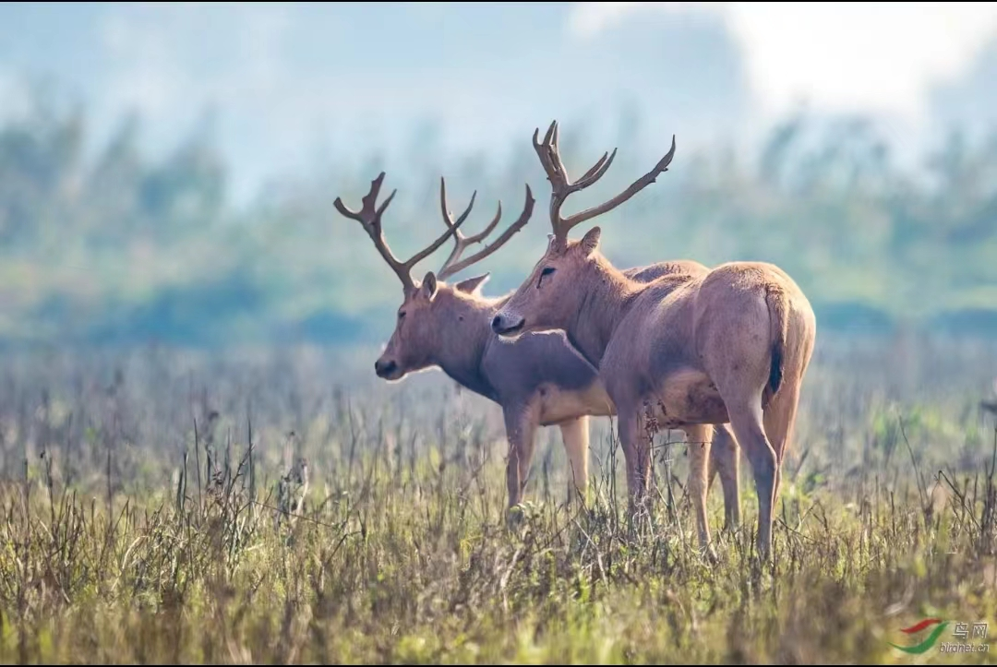
三、阅读下面短文，从所给选项中选出能填入空白处的最佳选项，使短文通畅，结构完整，其中有一项为多余选项(共5小题，每题2分，计10分)
Milu deer, a kind of animal with large horns(角) ,used to be common in China long ago. 1 People often killed Milu deer for food or sport.. 2 That is how the Milu deer disappeared(消失) from China.
Luckily, before all of them lost their lives, someone took some deer to Britain to improve the environment of the beautiful park which belonged to Duke of Bedford. He liked them so much that he took them from China to Britain. 3 As a result, when in 1985,the government of China wanted to bring back the Milu deer, the Duke of Bedford was able to help. The first deer came back to China to the Nanhaizi Milu Park 20 kilometres south of Beijing and the centre in Dafeng, Jiangsu Province.
4 There are now so many of them that people have opened a new centre for them in Hubei Province. 5 We hope that one day there will be enough animals to let them live in the wild again.
A.The Ming and Qing dynasties(朝代) did not protect them and killed many.
B.The deer certainly seem happy to be back in China because their number has grown quickly.
C.Like other deer, they lived together and ate grass and the soft parts of trees.
D.Since then, some deer have been introduced from Britain every year.
E.Milu deer liked the cool, wet weather in England and their number increased (增加)year by year.
F.At the moment the Milu deer live in centres where people protect and care for them.
1. 2. 3. 4. 5.

四、阅读短文并回答问题(共5小题，每题2分，计10分)
There is a reserve in Jiangsu called the Yancheng Reserve. A special girl worked there. Her name was Xu xiujuan. Xu Xiujuan came from Heilongjiang Province. She came to work in the Yancheng Reserve in 1986. For a long time, her family cared for cranes in the Zhalong Nature Reserve in North-east China.
The Zhalong Nature Reserve is the summer home of many red-crowned cranes. The cranes start their families there. In the Zhalong Nature Reserve,Xu Xiujuan’s job was to help the workers of the reserve care for the cranes when they had babies.
Xu Xiujuan enjoyed her work very much. In her diary she wrote “I love cranes and I love nature. when I walk in the countryside, I forget the unhappiness in my life”.
On 16th September 1987, two little cranes from the Yancheng Reserve flew into the wild and did not come back. It was evening. Xu Xiujuan was worried and went to look for them. Someone told her that a farmer caught the birds. She tried to get to the farmer’s house as quickly as possible. She took a short cut, but she had to cross a river. Sadly, the river was much deeper than she thought. The young girl lost her life when she was just twenty-three years old. Xu Xiujuan gave her life to the lovely red-crowned cranes.
回答下面的五个问题，每题答案不超过六个单词。
1. Where was Xu Xiujuan from?

2. What special animals live in Yancheng Nature Reserve?

3. Why did Xu Xiujuan love her job?

4. In which year did Xu Xiujuan die?

5. What do you think of Xu Xiujuan?

五、根据短文内容及首字母,填写所缺单词。（共10小题，每题1分，计10分）
Dear Mr President,
I want to do a project at school recently about wild animals in d 1 . I think their living condition(环境) is t 2 in China. I am writing to you to advise w 3 we should do to help protect animals more. I feel so s 4 for the giant panda. It’s one of the most popular animals in the world and a symbol of China. We learn that pandas m 5 live on bamboo. I think we should try to do more to stop people from destroying (破坏)their forests.
A 6 animal we should try to protect more is the Chinese alligator(扬子鳄). They live in some a 7 of eastern China, and now the water there isn’t c 8 enough for them to live in. The government should s 9 factories from polluting（污染）the lakes and rivers. If we protect these beautiful animals in China, more people may come to China to see them. They could be an important traveler attraction. It would be good if more people enjoyed v 10 our beautiful country, especially some quieter places in the country.
I hope you will encourage more people to think about such an important subject.
Yours sincerely,
Huang Jing
1. 2. 3. 4. 5.
6. 7. 8. 9. 10.
六、书面表达（计15分）
动物是人类的朋友，请以“Bears Are in Danger”为题，写一篇80词左右的文章。
要点：1、What do bears look like and what abilities do they have? ；
2、What danger are bears facing now?；
3、What should people do to protect bears?

__________________________________________________________________________________________________________________________________________________________________________
__________________________________________________________________________________________________________________________________________________________________________

__________________________________________________________________________________________________________________________________________________________________________

