2022—2023 学年度第一学期
学校 班级 姓名 学号
………………………密…………封…………线…………内…………不…………准…………答…………题………………………
八年级英语兴趣小组辅导练习（一）
（练习时间：50分钟 分值：70分 ）
一、完形填空（共15小题，每小题1分，计15分）
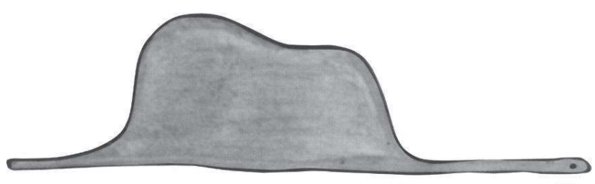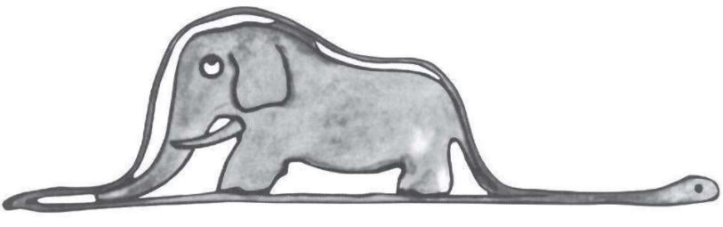
Drawing Number One Drawing Number Two
1 when I was six years old I saw a magnificent picture in a book, 2 True Stories from Nature, about the primeval(原始) forest. It was a picture of a boa(蟒) swallowing an animal. In the book it said, “Boa swallows their prey(猎物) whole, without chewing it. After that they are not 3 to move, and they sleep 4 the six months.”
I thought deeply, and after some work with a colored pencil I succeeded in making my first 5 . My Drawing Number One. I showed my masterpiece to the 6 , and asked them whether the drawing frightened them. But they answered, “Frighten? Why should anyone be frightened by a 7 ?” My drawing was not a picture of a hat. It was a boa digesting an elephant.
But 8 the grown-ups were not able to understand it, I made another drawing: I drew the inside of the boa, so that the grown-ups could see it 9 . They always need to have things 10 . I called it Drawing Number Two.
The grown-ups’ 11 , this time, was to advise me to put aside my drawings and spend my time
12 study. That is why, at the age of 13 , I gave up what might have been a good career as a
14 . Grown-ups never understand anything by 15 , and it is tiresome for children to be always and forever explaining things to them.
( )1. A. After B. Once C. And D. Ago
( )2. A. called B. said C. thought D. name
( )3. A. allowed B. care C. able D. easy
( )4. A. to B. until C. about D. through
( )5. A. drawing B. job C. homework D. dream
( )6. A. people B. children C. grown-ups D. teachers
( )7. A. boa B. hat C. elephant D. picture
( )8. A. then B. since C. when D. after
( )9. A. carefully B. careless C. clear D. clearly
( )10. A. see B. seen C. explain D. explained
( )11. A. question B. praise C. response D. word
( )12. A. to B. in C. at D. on
( )13. A. nine B. eight C. seven D. six
( )14. A. painter B. teacher C. writer D. animal watcher
( )15. A. they B. themselves C. them D. us

二、阅读理解（阅读选出最佳答案，共5小题，每小题2分，计10分）

“Watch out!” Chester shouted. “A cat!” He buried his head in the box. He didn’t want to see his new friend, Tucker Mouse, get killed. Back in hometown he had sometimes watched the fights of cats and mice in the meadow, and unless the mice were near their holes, the fights always ended in the same way. But this cat had been onto them too quickly: Tucker couldn’t have escaped.
There wasn’t a sound. Chester lifted his head and very cautiously looked. The cat—a huge tiger cat with gray-green eyes and black stripes along his body—was sitting on his legs. And directly between its paws(爪子), sat Tucker Mouse. He was watching Chester curiously. The cricket began to make sounds that the mouse should look up and see what was over him.
Very casually Tucker raised his head. The cat looked straight down on him. “Oh, him,” said Tucker, touching the cat under the chin with his right front paw, “he’s my best friend. Come out from the box.”
Chester crept(爬) out, looking first at one, then the other.
“Chester, meet Harry Cat,” said Tucker. “Harry, this is Chester. He’s a cricket.”
“I’m very pleased to make your acquaintance,” said Harry Cat in a silky voice.
“Hello,” said Chester. He was sort of shy because of all the fuss he’d made. “I wasn’t afraid for myself. But I thought cats and mice were enemies.”
“In the country, maybe,” said Tucker. “But in New York we gave up those old habits long ago. Harry is my oldest friend. Chester, make that sound again for Harry.”
Chester lifted the black wings, a beautiful sound echoed through the station.
( )1. Chester shouted “Watch out” because .
A. it was afraid B. it saw a cricket
C. it worried about Tucker D. it watched fights of cats and mice
( )2. Why couldn’t Tucker escape?
A. Because mice are afraid of cats. B. Because the cat was too quick.
C. Because mice can’t fight cats. D. Because the cat was huge.
( )3. The underlined word stripes probably means .
A. 形状 B. 颜色 C. 条纹 D. 毛发
( )4. What’s the relationship between Harry and Tucker?
A. Strangers B. Enemies C. Buddies D. Neighbors
( )5. What may Chester be?
A. Unknown. B. A rabbit. C. A dog. D. An insect.
三、阅读下面短文，从所给选项中选出能填入空白处的最佳选项， 使短文通畅，结构完整,， 其中有一项为多余选项。(共5小题，每题2分，计10分)
The fox appeared. “Good morning,” said the fox.
“Good morning,” the little prince answered politely, although when he turned around he saw nothing.
“ 1 ” the voice said, “under the apple tree. ”
“Who are you?” asked the little prince, and added, “You are very good-looking.”
“I am a fox,” said the fox.
“Come and play with me,” suggested the little prince. “ 2 ”
“I cannot play with you,” the fox said. “I am not tamed(驯化).”
“What does that mean—‘tame’?” said the little prince.
“You do not live here,” said the fox. “ 3 ”
“I am looking for men,” said the little prince.
“Men,” said the fox. “They have guns, and they hunt. 4 Are you looking for chickens?”
“No,” said the little prince. “I am looking for friends. What does tame mean?”
“It is an act too often neglected(忽视),” said the fox. “It means to establish ties(羁绊).”
“To establish ties?”
“Just that,”said the fox. “To me, you are still nothing more than a little boy who is just like a hundred thousand other little boys. And I have no need of you. And you, on your part, have no need of me. To you, I am nothing more than a fox like a hundred thousand other foxes. 5 To me, you will be unique in all the world. To you, I shall be unique in all the world...”
A. What are you looking for?
B. They also raise chickens.
C. I am right here.
D. I am so unhappy.
E. We will be friends forever.
F. But we shall need each other if you tame me.
1. 2. 3. 4. 5.
四、阅读短文并回答问题 (共5小题，每题2分，计10分)
Marva stood by the door to welcome the children as they walked past her into the classroom. “I love your sweater,” she told one of the boys. “Hello, sweetheart,” she said, her large hand touched a girl’s chin, “who made your hair so beautiful?” She told a boy who tried to push ahead of others, “What good-looking shoes you have. Tie the laces, so you don’t fall and hurt yourself.” Marva made sure she found something to praise in each child everyday, even if it was nothing more than the color of their socks, a new pencil or a bright smile.
The children ran to their seats and began taking out pencils and books. Four boys talked about after-school plans and a girl named Nancy in front was combing her hair. Marva walked past and took the comb from the girl. “Darling, put the comb away. Do you see my combing my hair in class? Do what you see me do. How would it look if I came to the class with a wet towel in my hand? Washing our faces and brushing our teeth are all the things we do in a private place.”
回答下面5个问题，每题答案不超过6个词。
1. Why did Marva ask the boy to tie the laces?

2. What did Marva do everyday?

3. What was Nancy doing?

4. Where should we comb our hair?

- What do you think of Marva?

五、根据短文内容及首字母,填写所缺单词。（共10小题，每题1分，计10分）
Marva Collins is a great teacher and educator. Before setting up her own school, she worked as a teacher and has turned down the phone calls from the US presidents twice. The presidents a 1 her to work as the Education Minister(教育部长). But she said she l 2 the classroom and her s 3 too much and she belongs to them. Marva s 4 criticized the students. When s 5 made a mistake, she would ask him/her to write down one h 6 good things about himself/herself. The students said, “I won’t make m 7 anymore, because I am tired of telling my teacher how e 8 I am!” Collins was a black woman. At that time, it is almost impossible for a black person to find a good job or be a teacher. But Collins w 9 hard and finally made it. She herself is a wonderful s 10 !
1. 2. 3. 4. 5.
6. 7. 8. 9. 10.
六、书面表达。（计15分）
假如你当上了自己所在中学的校长，学校会变成什么样呢？写出你理想中的学校。
My ideal school
starts at… ends at…
basketball fields / library
… hours of homework
after-school activities/clubs

要求：1.词数90左右，开头已给出，不计入总词数
2.可以包括以上要点，也可自行发挥
3.文中不得出现真实的人名、校名、地名等相关信息
If I become the principal (校长) of my school, I would make it like this:
Our school
_______________________________________________________________________________________________________________________________________________________________________________________________________________________________________________________________
__________________________________________________________________________________________________________________________________________________________________________

__________________________________________________________________________________________________________________________________________________________________________

